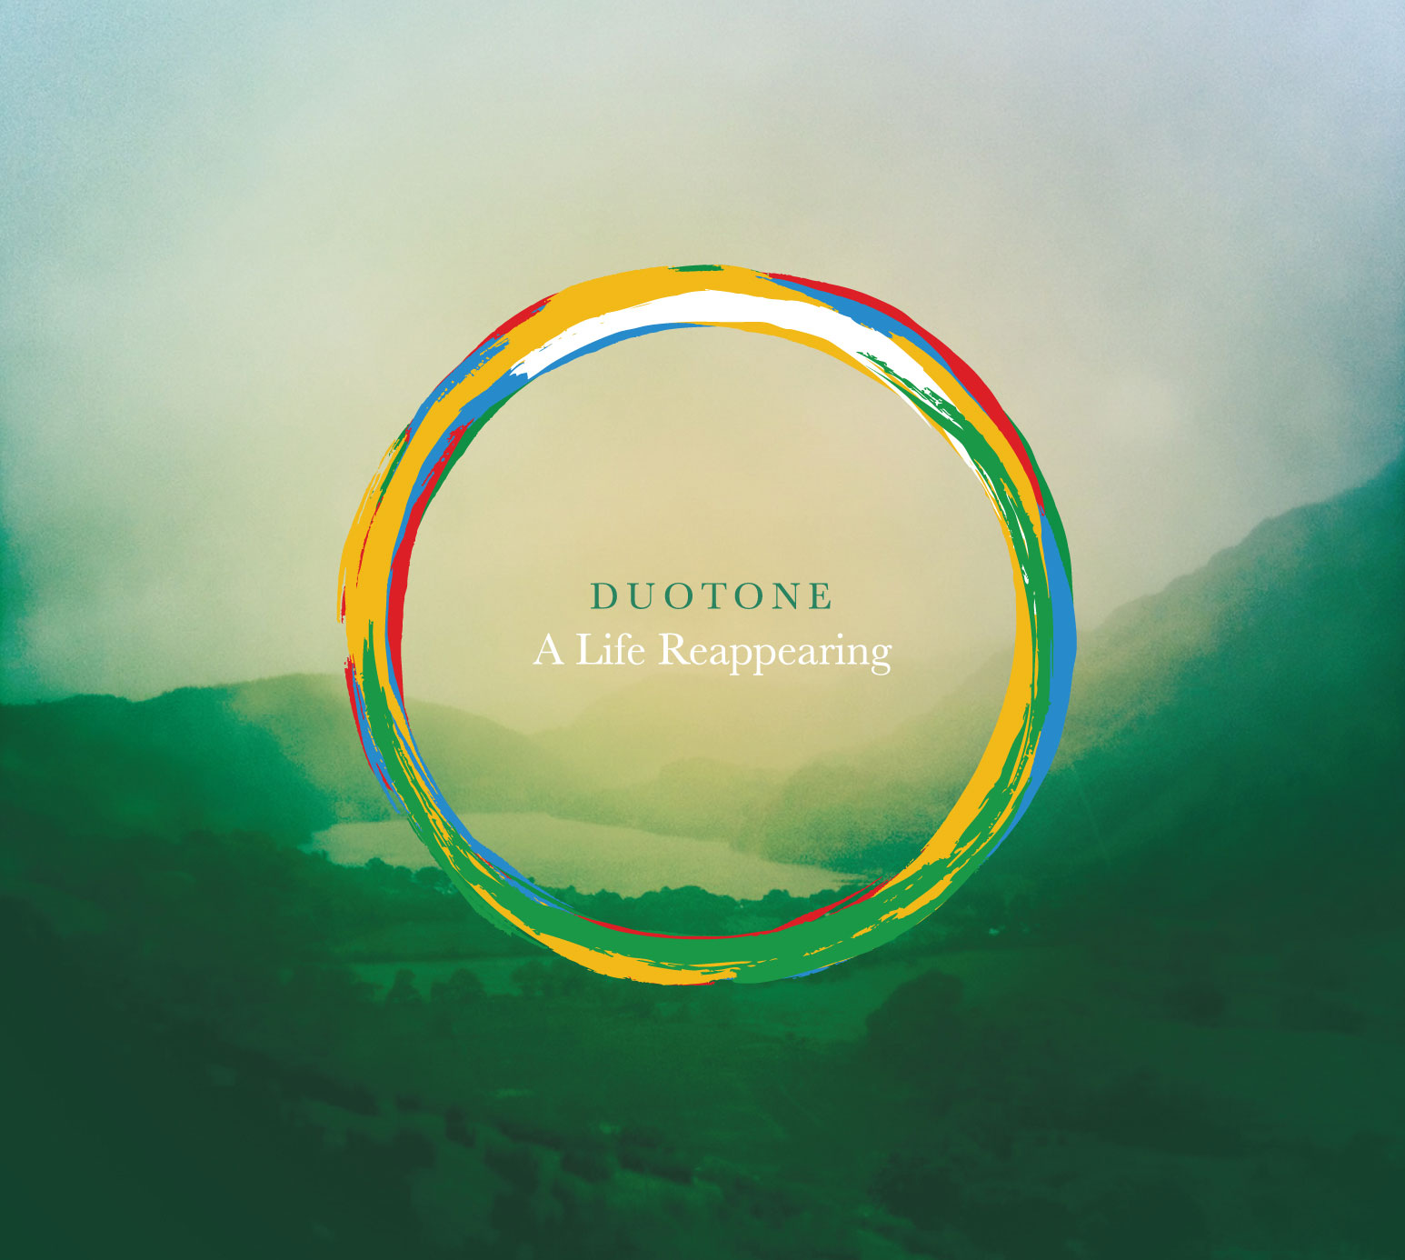
Duotone
A Life Reappearing
New Album Released: 4th May
Label: Garrett Brown Music
Formats: CD | Digital
Catalogue no.: GBMCD0005 | GBMDL0005

“A hidden gem.” - The Observer / “Seriously spellbinding.” – fRoots

***** Songlines / ***** Maverick / **** Telegragh

Duotone (the alias of multi-instrumentalist, songwriter and live looper Barney Morse-Brown) releases his spellbinding new album A Life Reappearing on 4th May. Like an alchemist Duotone weaves a plethora of instruments of an epic orchestral power - including his pioneering and unconventional cello playing - with a masterful use of a looper for his gentle vocals, which wraps each song in a blanket of intimacy.

Duotone’s music is inspired by life, death and art. Whilst his first three albums, Work Harder & One Day You’ll Find Her (2009, GBM), the critically-acclaimed Ropes (2011, ECC records) and Let’s Get Low (2015, GMB), saw Duotone navigating his way through personal loss, forthcoming fourth album A Life Reappearing is inspired by
a book of paintings by Victoria Crowe. The book charts the remarkable life of Scottish shepherd Jenny Armstrong and Duotone's visceral response to Crowe's art gave him the spark to create; the unexpected parallels between his and Jenny's lives, and his reflections upon them, a wealth of material. The outcome is eight exquisitely-crafted new songs which muse upon the cycle of life and our journey from the dark to the light.

Barney learnt the cello at age six, he went on to study at Royal Welsh College of Music & Drama and to win a scholarship in baroque cello at the Royal College of Music. He has been mesmerising audiences around the UK and further afield since releasing his first album in 2009 including standout performances at Union Chapel, Birmingham Town Hall and End of the Road Festival.

In addition to his solo work as Duotone, Barney has performed and recorded with high-profile musicians including Syrian Qanun player Maya Youssef, folk illuminati Jackie Oates, The Imagined Village, Eliza Carthy, Chris Wood and multi-platinum award-winning artist Birdy, with whom he toured all over the world.

A Life Reappearing was written and recorded by Duotone at home, Borth-Y-Gest, North Wales and at Starling Audio, Oxford. Additional recording and mixing by Richard Neuberg at Strawhouse. Duotone performs vocals, cello, guitar (acoustic, classical and electric), percussion and bass; alongside Jane Griffiths on viola, violin and piano (on A Life Disappearing, Hear You Whisper, The Faintest and The Room respectively) and Adam Falkner on drums (The Faintest). Pete Thomas also guests on bass on Marta and award-winner folk artist Kris Drever sang guest vocals on The Faintest.
LIVE:
April: 14: South Street Arts, Reading | 16: Kitchen Garden Cafe, Birmingham | 21: Eype Church, Bridport |
22: The Lighthouse, Folkestone | 27: Folk at the Foundling, London | 28: Modern Art, Oxford

May: 6: Musicport Mini Music festival | 12: The Drawing Room, Chesham

Connect with Duotone via:
Website: www.duotonemusic.com | Facebook: @duotoneofficial | Twitter @Duotonemusic

Press contact – Hannah Gould PR: hannahgould@hannahgould.co.uk | 07974 000415

